**PROJECT REPORT**

**ON**

Impact of 5g networks on biomedical

**Submitted by:**

**RAJ KUMAR MISHRA**

**21111041**

**1st semester**

**Biomedical**

**National Institute Of Technology, Raipur**

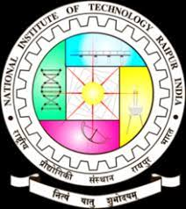

Under the Supervision of:

**Dr** Saurabh Gupta

Basic Biomedical

**ACKNOWLEDGEMENT**

**I am grateful to Dr Saurabh sir of Biomedical department for his proficient supervision of the term project on “Impact of 5g networks on biomedical”. I convey my sincere respect and deep gratitude to Dr Saurabh sir for her inspiration, cooperation, and encouragement .Her valuable suggestions and guidance helped me a lot to complete my work in this institution within the stipulated time. I render my sincere respect and gratitude to all the faculty members, for their valuable suggestions towards the completion of this project work. I am also grateful to all my classmates, who helped me directly or indirectly in completing my project work successfully.**

**Raj Kumar Mishra**

**21111041**

**1st semester**

**Biomedical**

**National Institute Of Technology, Raipur**

**Introduction**

### This project discusses about the impact of 5g on the various field of biomedical. 5G technology will help turn antiquated healthcare systems in hospitals into smart hospitals that can deliver remote healthcare services to patients around the world. 5G opens entirely new horizons for telehealth, the technology that allows patients to connect virtually with doctors and other healthcare providers, communicating via real-time video or live chat. The [healthcare](https://www.telit.com/industries-solutions/healthcare/) IT market is continuously searching for new ways advanced technology can play a more impactful role in transforming healthcare delivery.

### o Learn how the low latency, high reliability, and rapid speeds of 5G networks stand to change healthcare for good – from remote diagnosis to medical monitoring systems.

## Telehealth

A pre-COVID-19 study by Market Research Future found that the telehealth market is expected to grow at a compound annual growth rate of parallel with the emergence and rollout of 5G. It is foregone that these are likely to be higher growth rates now. Faster network speeds and the quality of care will allow doctors to engage remotely with patients at home or in field hospitals without the worry of network blackouts, disconnections or lag time.In the aftermath of the Coronavirus pandemic, 5G technology will enable remote support of quality healthcare while reducing patient exposure to contagion by minimizing in-person visits to the doctor or healthcare facilities. For patients who can’t easily travel to their healthcare providers, 5G will allow the provider to visit them via natural-feeling telepresence systems.As a result, critical healthcare services can be delivered over a wireless network for chronically ill or quarantined patients. With the emergence of 5G, it might mean the difference between life and death for many.

## 

## Real-Time Remote Monitoring

With [5G-enabled wearable devices](https://www.telit.com/industries-solutions/healthcare/wearables/), healthcare providers can monitor patients remotely and gather real-time data for preventative care and other individually-tailored healthcare provisions. This engagement is expected to decrease hospital costs  over the next five years. Patients with chronic conditions can also retain autonomy and improve outcomes with more reliable, always-on mobile personal emergency response systems. AT&T [notes](https://www.business.att.com/learn/updates/how-5g-will-transform-the-healthcare-industry.html) that even though remote technology brings many benefits, usage is “limited by the capacity of the network to handle the data.” A slow network with unreliable connections could result in doctors unable to meet with patients and obtain critical healthcare data about them, especially in an emergency.5G technology reduces the chances of this happening and allows healthcare providers to deliver treatment seamlessly to chronically ill patients across the fastest network available.

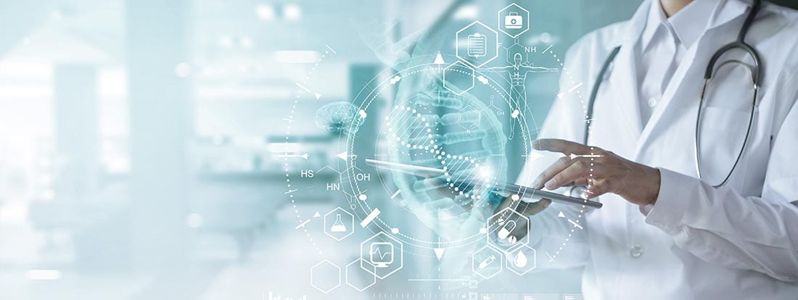

## Sensor Innovation

Innovations in medical device  will provide more medical gadgets to patients who can reliably measure and monitor their health from home. These do-it-yourself innovations in healthcare will calibrate, gather and validate data from trusted sensors. The data can then be transmitted to a variety of medical and health care professionals for analysis.The entry included a sensor that fits into the palm of your hand and is as user-friendly as your smartphone, enabling patients to easily measure their health at home. This was a major advancement, but one sensor alone really isn’t enough. The combination of numerous patient Internet of Medical Things (IoMT) devices and sensors helps doctors provide a complete health picture for their patients, leading to a personalized health treatment program.

CONCLUSION

5G networks provide greater facilities in biomedical field.

It has contribution in improving medical and hospital facilities of our country. It enables doctor to communicate patients present in the long distance. It can also become a major source in providing medical facilities to patients present in the rural areas. It also provides more precise and accurate data of the patients to the doctor at any point of time during their treatment. We can save life of patients in emergency situations by the quick online health care services. Thus we can conclude that with the presence of 5g networks we can improve the health care system of our country.

### Thank you